Appendix A. Supplementary data

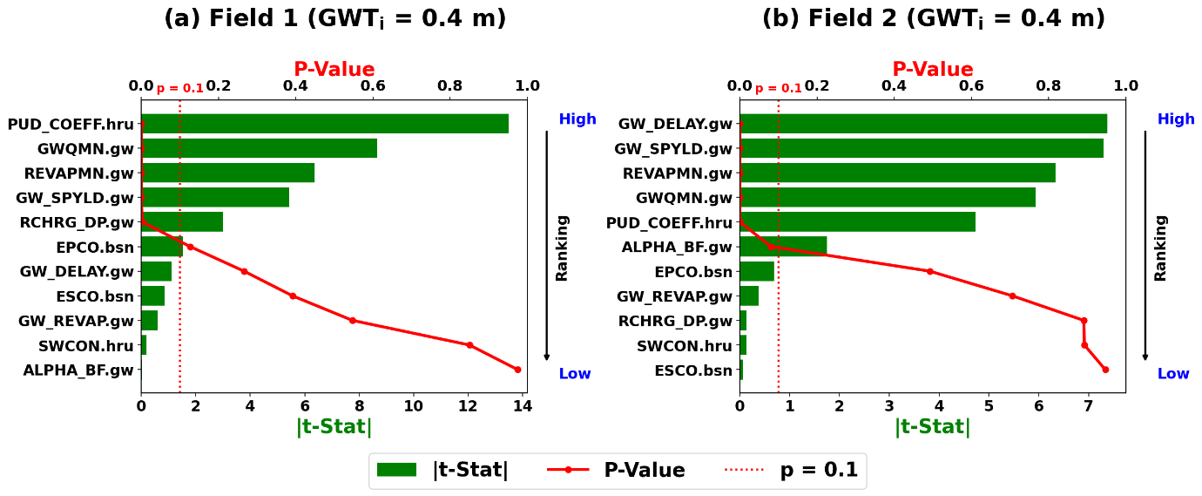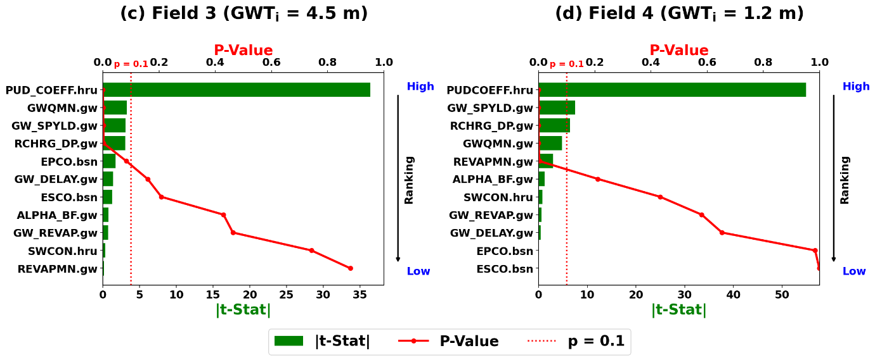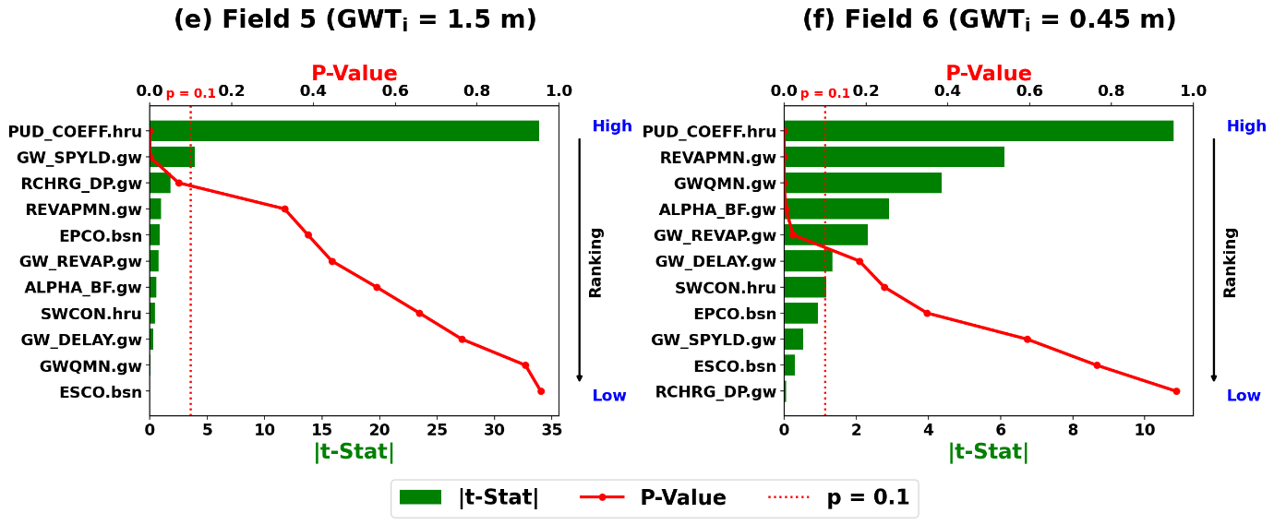
Fig. 1. Sensitivity analysis of the chosen parameters in SWAT-Rice with rankings for Fields 1 to 6 (GWT_{i} is the initial depth of the groundwater table).

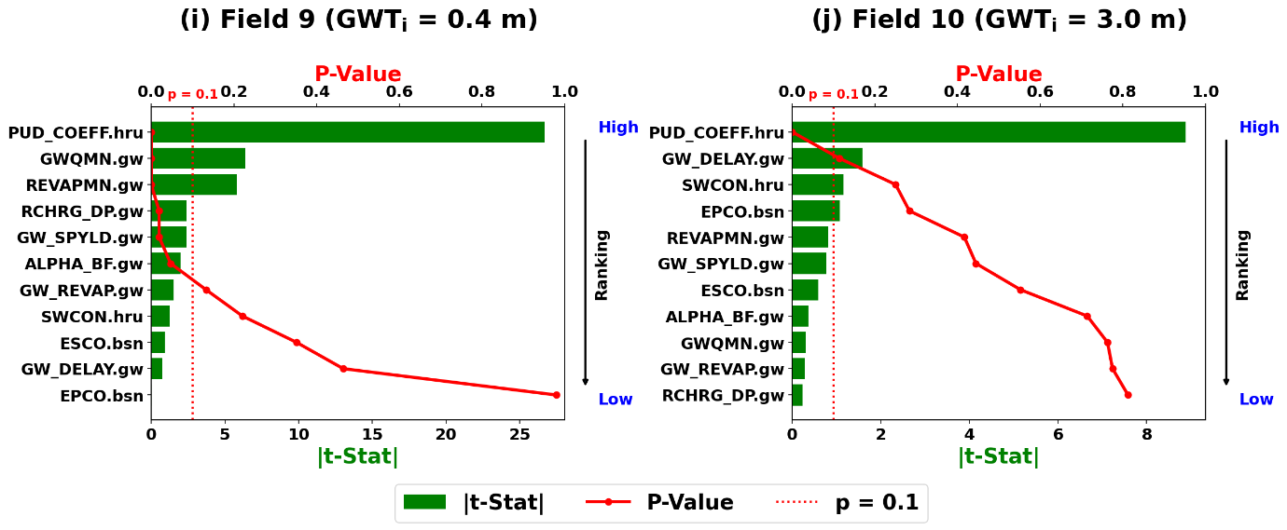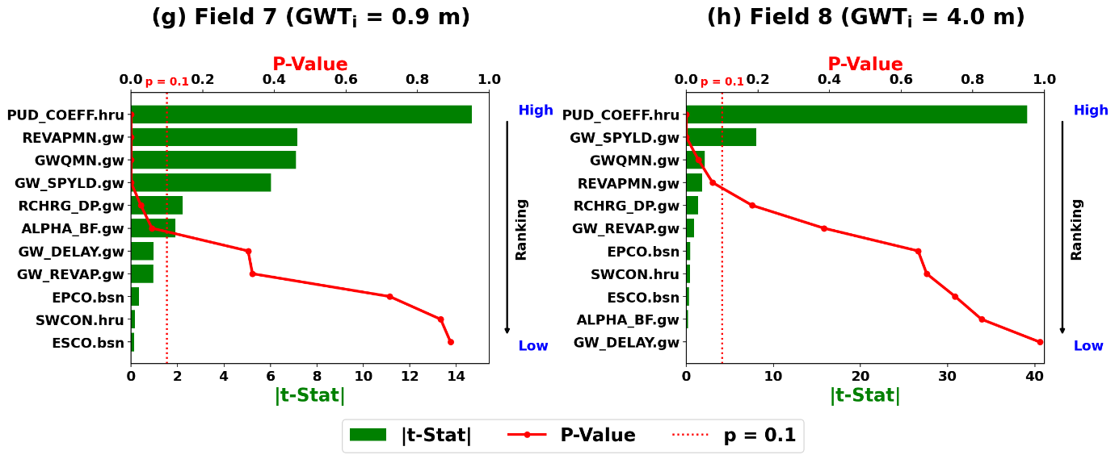
Fig. 2. Sensitivity analysis of the chosen parameters in SWAT-Rice with rankings for Fields 7 to 10 (GWT_{i} is the initial depth of the groundwater table).

Field | Parameter | Fitted value | Minimum value | Maximum value
1 | v__GWQMN.gw | 2021.250 | 2000.000 | 3000.000
 | v__PUD_COEFF.hru | 0.510 | 0.000 | 0.600
 | v__GW_SPYLD.gw | 0.173 | 0.010 | 0.200
 | v__RCHRG_DP.gw | 0.099 | 0.000 | 0.200
 | v__REVAPMN.gw | 2828.750 | 2000.000 | 3000.000
2 | v__ALPHA_BF.gw | 0.412 | 0.000 | 0.500
 | v__GW_DELAY.gw | 15.379 | 0.000 | 15.000
 | v__GWQMN.gw | 2326.250 | 2000.000 | 3000.000
 | v__PUD_COEFF.hru | 0.526 | 0.000 | 0.600
 | v__GW_SPYLD.gw | 0.179 | 0.010 | 0.200
 | v__REVAPMN.gw | 2707.500 | 2000.000 | 3000.000
3 | v__GWQMN.gw | 2657.000 | 2000.000 | 3000.000
 | v__PUD_COEFF.hru | 0.574 | 0.000 | 0.600
 | v__EPCO.bsn | 0.993 | 0.000 | 1.000
 | v__GW_SPYLD.gw | 0.183 | 0.010 | 0.200
 | v__RCHRG_DP.gw | 0.575 | 0.000 | 1.000
4 | v__GWQMN.gw | 2607.500 | 2000.000 | 3000.000
 | v__PUD_COEFF.hru | 0.170 | 0.000 | 0.600
 | v__GW_SPYLD.gw | 0.037 | 0.010 | 0.200
 | v__RCHRG_DP.gw | 0.757 | 0.000 | 1.000
 | v__REVAPMN.gw | 2592.500 | 2000.000 | 3000.000
5 | v__PUD_COEFF.hru | 0.118 | 0.000 | 0.600
 | v__GW_SPYLD.gw | 0.044 | 0.020 | 0.060
 | v__RCHRG_DP.gw | 0.397 | 0.000 | 0.400
6 | v__ALPHA_BF.gw | 0.052 | 0.000 | 0.500
 | v__GW_DELAY.gw | 9.108 | 0.000 | 15.000
 | v__GWQMN.gw | 1873.662 | 2000 | 3000
 | v__PUD_COEFF.hru | 0.301 | 0.000 | 0.600
 | v__GW_REVAP.gw | 0.134 | 0.020 | 0.200
 | v__REVAPMN.gw | 2940.191 | 2000 | 3000.000
7 | v__GWQMN.gw | 2362.848 | 2000 | 3000.000
 | v__PUD_COEFF.hru | 0.564 | 0.000 | 0.600
 | v__GW_SPYLD.gw | 0.197 | 0.010 | 0.200
 | v__RCHRG_DP.gw | 0.115 | 0.000 | 0.200
 | v__REVAPMN.gw | 2157.857 | 2000.000 | 3000.000
 | v__ALPHA_BF.gw | 0.526 | 0.000 | 1.000
8 | v__GWQMN.gw | 2587.500 | 2000.000 | 3000.000
 | v__PUD_COEFF.hru | 0.140 | 0.000 | 0.600
 | v__GW_SPYLD.gw | 0.097 | 0.010 | 0.200
 | v__REVAPMN.gw | 2962.500 | 2000.000 | 3000.000
9 | v__GWQMN.gw | 2532.500 | 2000.000 | 3000.000
 | v__PUD_COEFF.hru | 0.025 | 0.000 | 0.600
 | v__RCHRG_DP.gw | 0.030 | 0.000 | 0.200
 | v__REVAPMN.gw | 2067.500 | 2000.000 | 3000.000
 | v__ALPHA_BF.gw | 0.158 | 0.000 | 0.500
10 | v__PUD_COEFF.hru | 0.286 | 0.000 | 0.600
Table 1. Fitted parameter values and parameter ranges for Fields 1–10 using SWAT-Rice model.

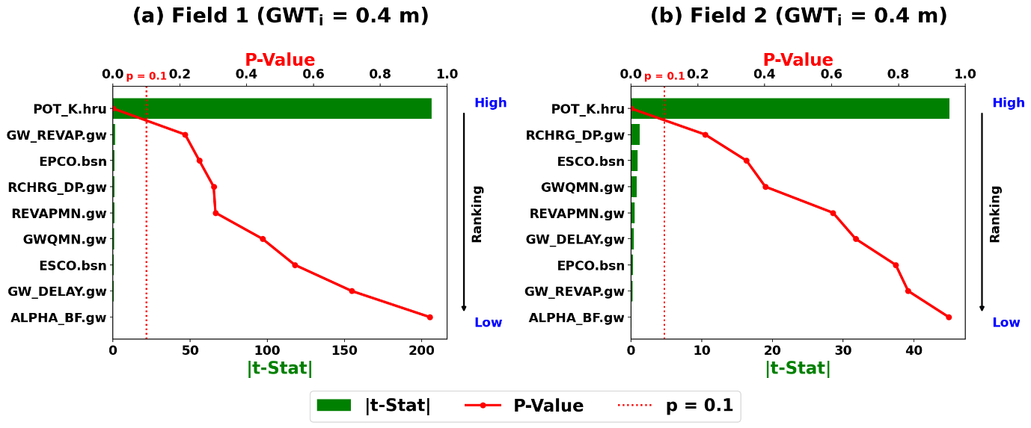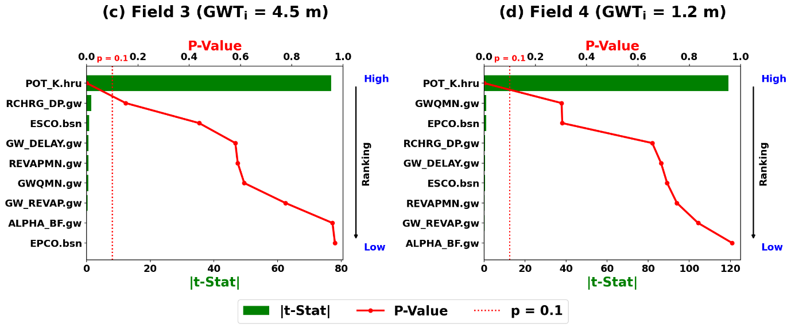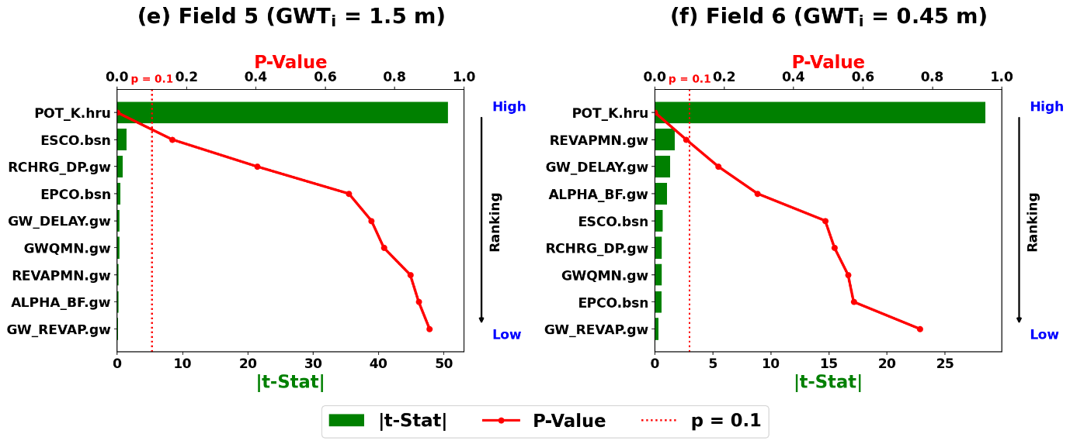
Fig. 3. Sensitivity analysis of the chosen parameters in SWAT-P with rankings for Fields 1 to 6 (GWT_{i} is the initial depth of the groundwater table).

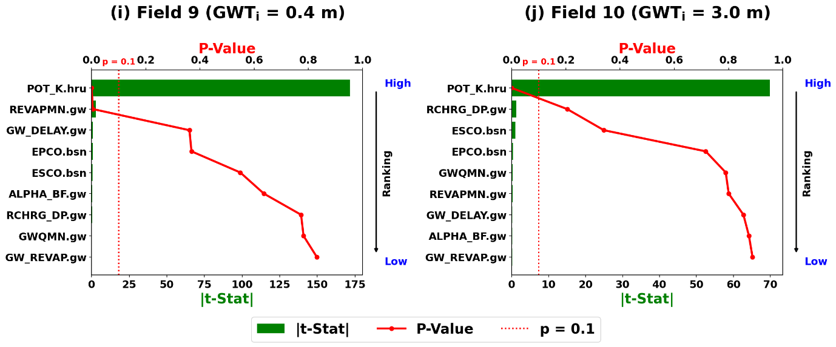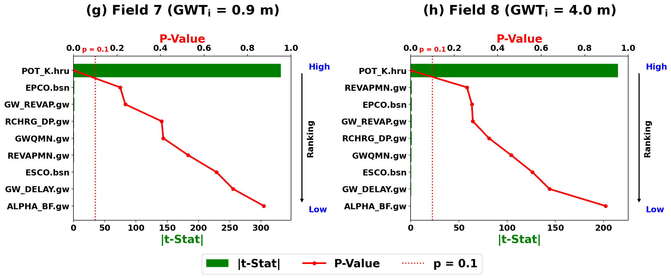
Fig. 4. Sensitivity analysis of the chosen parameters in SWAT-P with rankings for Fields 7 to 10 (GWT_{i} is the initial depth of the groundwater table).

Table 2. Fitted parameter values and parameter ranges for Fields 1–10 using SWAT-P model
Field | Parameter | Fitted value | Minimum value | Maximum value
1 | v__POT_K.hru | 0.289 | 0.000 | 0.290
2 | v__POT_K.hru | 0.289 | 0.000 | 0.290
3 | v__POT_K.hru | 0.297 | 0.000 | 0.290
4 | v__POT_K.hru | 0.289 | 0.000 | 0.290
5 | v__POT_K.hru | 0.289 | 0.000 | 0.290
6 | v__POT_K.hru | 0.100 | 0.000 | 0.290
 | v__REVAPMN.gw | 3490.000 | 2000.000 | 4000.000
7 | v__POT_K.hru | 0.289 | 0.000 | 0.290
8 | v__POT_K.hru | 0.289 | 0.000 | 0.290
 | v__REVAPMN.gw | 3170.000 | 2000.000 | 4000.000
9 | v__POT_K.hru | 0.289 | 0.000 | 0.290
10 | v__POT_K.hru | 0.289 | 0.000 | 0.290

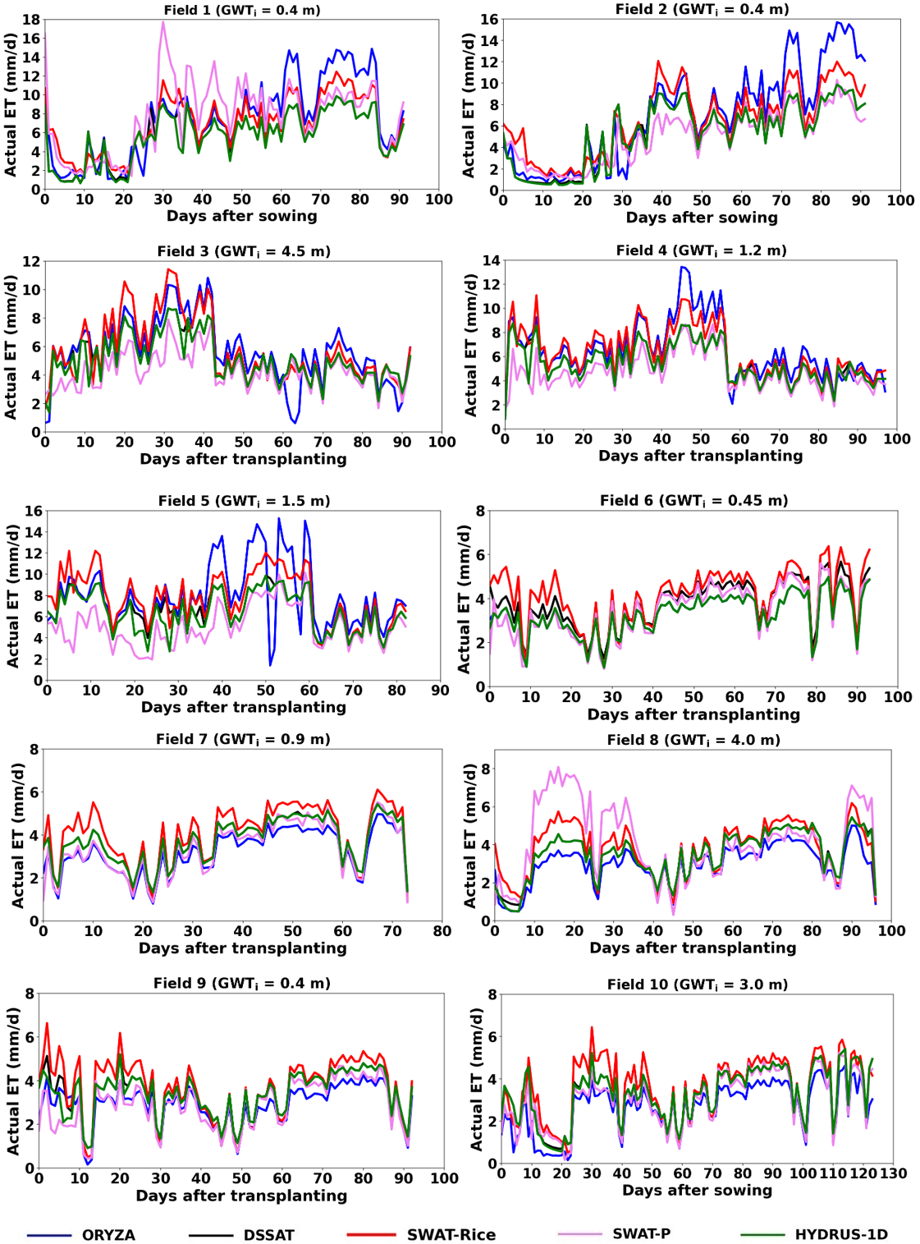
Fig. 5. Simulated daily evapotranspiration by different models for Fields 1 to 10.
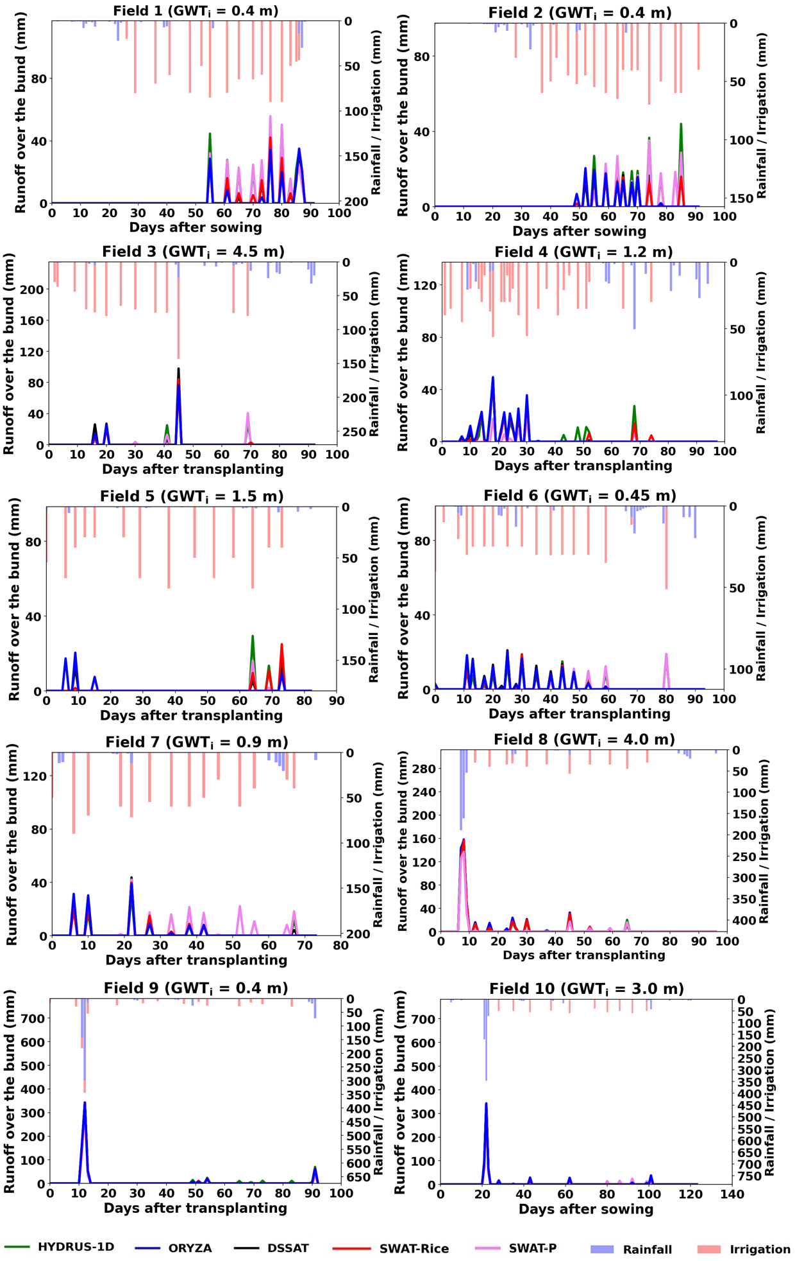
Fig. 6. Simulated daily runoff over the bund by different models for Fields 1 to 10.
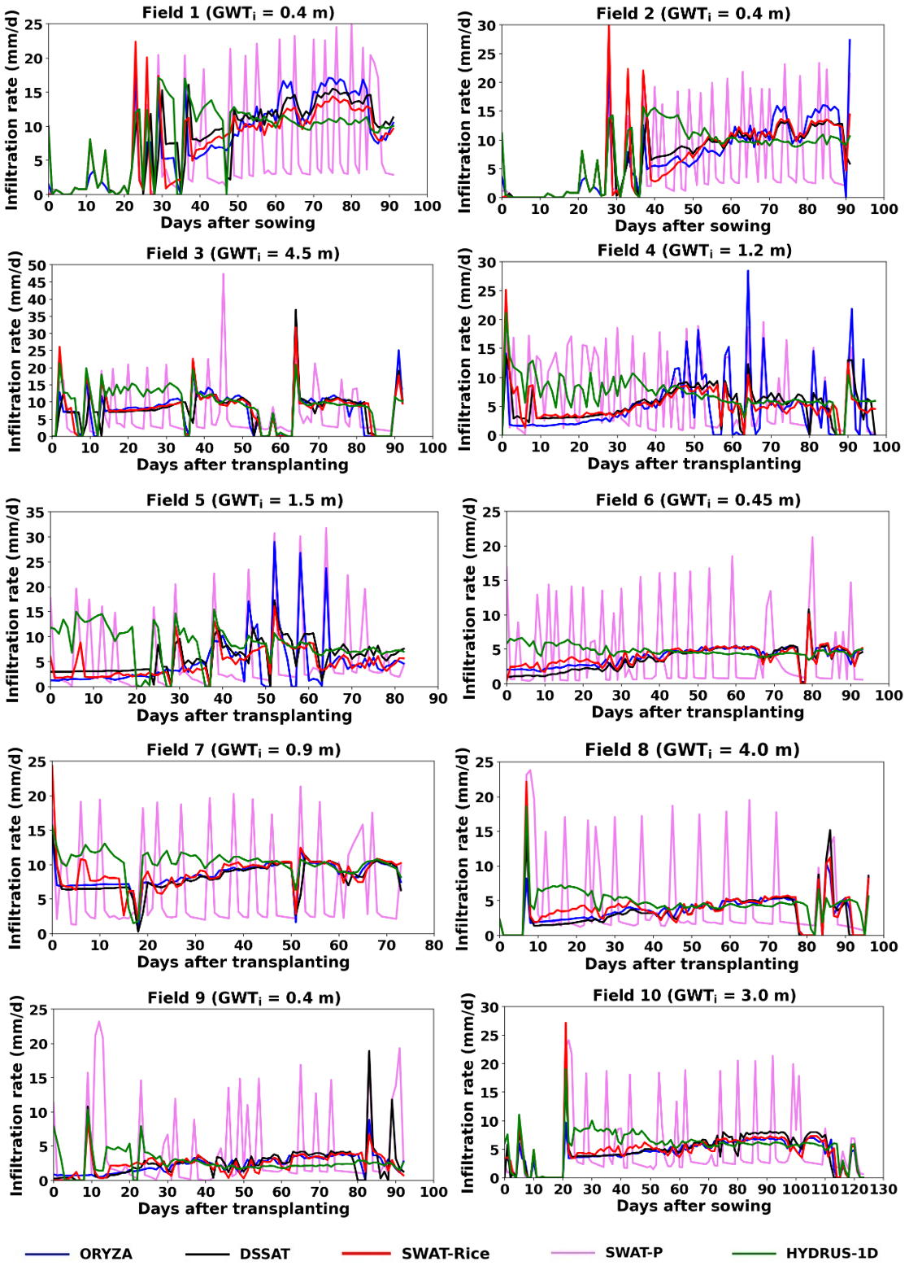
Fig. 7. Simulated daily infiltration rate by different models for Fields 1 to 10.

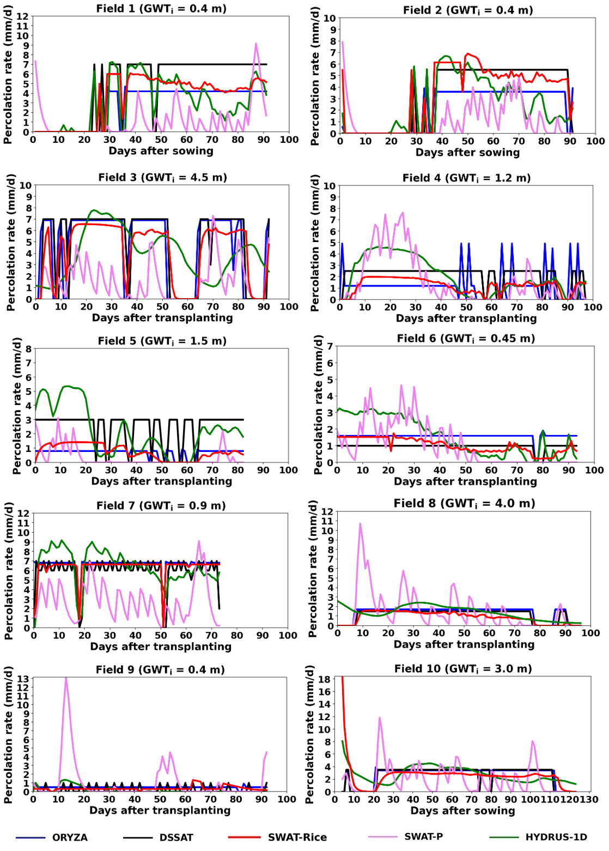
Fig. 8. Simulated daily percolation rate by different models for Fields 1 to 10.

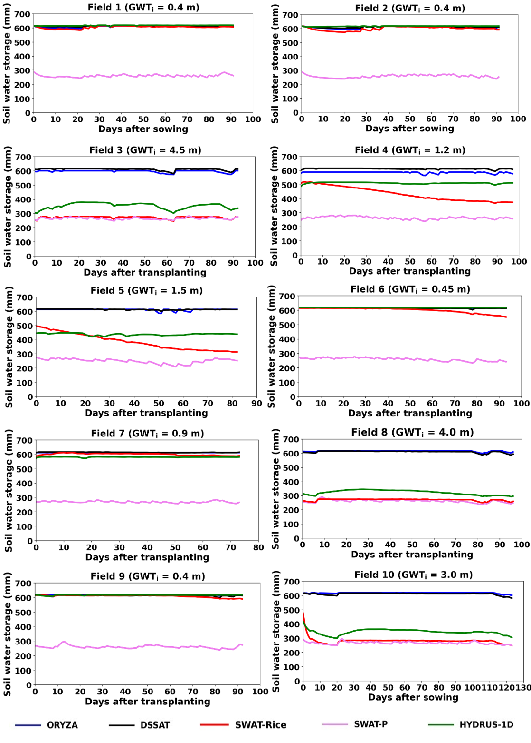
Fig. 9. Simulated daily soil water storage by different models for Fields 1 to 10.

Table 3. Performance statistics of water balance components relative to HYDRUS-1D simulations for Farmer Fields 1–5 in Kar season.
Farmer  field | Water  balance  component | NSE |  |  |  | R-square |  |  |  | RMSE |  |  |  | PBIAS
 |  | ORYZA | DSSAT | SWAT-  Rice | SWAT-P | ORYZA | DSSAT | SWAT-  Rice | SWAT-P | ORYZA | DSSAT | SWAT-  Rice | SWAT-P | ORYZA | DSSAT | SWAT-  Rice | SWAT-P
1 | Runoff over  the bund | 0.68 | 0.80 | 0.85 | 0.95 | 0.76 | 0.87 | 0.91 | 0.95 | 5.87 | 4.68 | 4.03 | 2.34 | -48.68 | -39.09 | -32.45 | -5.26
 | Percolation | 0.50 | 0.00 | 0.56 | < 0.00 | 0.50 | 0.61 | 0.63 | 0.01 | 1.85 | 2.61 | 1.73 | 33.01 | -2.52 | 54.30 | 19.69 | 54.83
 | Infiltration | 0.26 | 0.51 | 0.34 | < 0.00 | 0.47 | 0.58 | 0.49 | 0.17 | 4.34 | 3.55 | 4.10 | 7.48 | -5.16 | 0.65 | -9.66 | -27.95
 | Soil water  storage | < 0.00 | < 0.00 | < 0.00 | < 0.00 | 0.59 | 0.04 | 0.39 | 0.20 | 8.27 | 6.58 | 14.58 | 356.34 | -1.13 | -0.94 | -2.04 | -57.71
2 | Runoff over  the bund | 0.34 | 0.77 | 0.67 | 0.79 | 0.37 | 0.88 | 0.77 | 0.79 | 6.42 | 3.77 | 4.58 | 3.66 | -48.44 | -35.71 | -40.51 | -14.14
 | Percolation | 0.53 | 0.28 | 0.35 | < 0.00 | 0.53 | 0.61 | 0.60 | 0.03 | 1.68 | 2.07 | 1.96 | 32.81 | -6.30 | 45.29 | 41.09 | 91.79
 | Infiltration | 0.11 | 0.68 | 0.14 | < 0.00 | 0.41 | 0.71 | 0.43 | 0.20 | 4.80 | 2.86 | 4.74 | 7.07 | -9.72 | -6.68 | -7.45 | -24.88
 | Soil water  storage | < 0.00 | < 0.00 | < 0.00 | < 0.00 | 0.45 | 0.39 | 0.45 | 0.26 | 8.27 | 7.74 | 21.16 | 359.03 | -0.81 | -1.15 | -2.89 | -58.17
3 | Runoff over  the bund | 0.83 | 0.84 | 0.81 | 0.92 | 0.83 | 0.87 | 0.82 | 0.92 | 3.71 | 3.52 | 3.86 | 2.53 | -38.53 | -14.90 | -37.98 | -13.88
 | Percolation | < 0.00 | < 0.00 | 0.85 | 0.56 | 0.01 | 0.01 | 0.98 | 0.97 | 18.43 | 18.43 | 7.10 | 12.12 | -32.62 | -32.43 | 7.57 | -29.97
 | Infiltration | 0.57 | 0.35 | 0.70 | < 0.00 | 0.65 | 0.46 | 0.75 | 0.22 | 3.94 | 4.82 | 3.26 | 7.35 | -18.30 | -16.63 | -14.79 | -31.94
 | Soil water  storage | < 0.00 | < 0.00 | < 0.00 | < 0.00 | 0.41 | 0.33 | 0.62 | 0.32 | 247.65 | 261.08 | 81.46 | 89.32 | 70.52 | 74.34 | -22.83 | -24.83
4 | Runoff over  the bund | 0.73 | 0.83 | 0.88 | 0.44 | 0.78 | 0.85 | 0.89 | 0.72 | 3.47 | 2.74 | 2.31 | 5.03 | 2.38 | -5.84 | -3.89 | -76.15
 | Percolation | < 0.00 | 0.01 | 0.18 | < 0.00 | 0.00 | 0.02 | 0.33 | 0.98 | 9.56 | 9.22 | 8.41 | 19.88 | -52.90 | -25.51 | -47.07 | 56.88
 | Infiltration | < 0.00 | 0.05 | 0.20 | < 0.00 | 0.08 | 0.34 | 0.46 | 0.11 | 5.84 | 3.63 | 3.33 | 6.27 | -35.65 | -24.69 | -26.91 | -11.47
 | Soil water  storage | < 0.00 | < 0.00 | < 0.00 | < 0.00 | 0.12 | 0.72 | 0.06 | 0.47 | 80.48 | 103.59 | 85.15 | 245.43 | 15.70 | 20.35 | -10.36 | -48.26
5 | Runoff over  the bund | < 0.00 | 0.21 | 0.54 | 0.72 | 0.01 | 0.23 | 0.55 | 0.91 | 4.07 | 2.90 | 2.22 | 1.74 | -2.34 | -38.76 | -15.70 | -53.27
 | Percolation | < 0.00 | 0.00 | 0.11 | 0.06 | 0.01 | 0.01 | 0.55 | 0.99 | 15.67 | 15.39 | 14.55 | 14.98 | -81.86 | -40.45 | -74.68 | -8.04
 | Infiltration | < 0.00 | < 0.00 | < 0.00 | < 0.00 | 0.03 | 0.18 | 0.16 | 0.14 | 7.33 | 5.29 | 5.84 | 7.63 | -48.30 | -34.75 | -45.19 | -39.82
 | Soil water  storage | < 0.00 | < 0.00 | < 0.00 | < 0.00 | 0.29 | 0.53 | 0.00 | 0.27 | 173.84 | 176.24 | 85.90 | 185.09 | 39.80 | 40.36 | -2.80 | -42.31

Table 4. Performance statistics of water balance components relative to HYDRUS-1D simulations for Farmer Fields 6–10 in Pishanam season.
Farmer  field | Water  balance  component | NSE |  |  |  | R-square |  |  |  | RMSE |  |  |  | PBIAS
 |  | ORYZA | DSSAT | SWAT-  Rice | SWAT-P | ORYZA | DSSAT | SWAT-  Rice | SWAT-P | ORYZA | DSSAT | SWAT-  Rice | SWAT-P | ORYZA | DSSAT | SWAT-  Rice | SWAT-P
6 | Runoff over  the bund | 0.99 | 0.99 | 0.99 | 0.98 | 0.99 | 0.99 | 0.99 | 0.99 | 2.78 | 2.73 | 2.48 | 3.08 | 4.62 | 3.97 | -0.95 | -20.48
 | Percolation | 0.20 | < 0.00 | 0.30 | < 0.00 | 0.25 | 0.26 | 0.67 | 0.04 | 1.24 | 1.45 | 1.16 | 28.21 | -7.55 | -44.46 | -33.25 | 135.68
 | Infiltration | < 0.00 | < 0.00 | < 0.00 | < 0.00 | 0.07 | 0.03 | 0.08 | 0.01 | 2.29 | 2.84 | 2.64 | 5.78 | -26.49 | -33.28 | -28.13 | -12.50
 | Soil water  storage | 0.35 | < 0.00 | < 0.00 | < 0.00 | 0.36 | 0.56 | 0.00 | 0.04 | 1.96 | 3.86 | 21.57 | 355.91 | -0.03 | -0.52 | -2.12 | -57.67
7 | Runoff over  the bund | 0.98 | 0.98 | 0.98 | 0.93 | 0.98 | 0.99 | 0.98 | 0.94 | 2.64 | 2.53 | 2.93 | 5.17 | 9.09 | 10.93 | 3.74 | 24.61
 | Percolation | 0.23 | 0.25 | 0.33 | < 0.00 | 0.23 | 0.28 | 0.36 | 0.66 | 4.32 | 4.24 | 4.03 | 28.28 | -1.15 | -13.36 | -4.84 | 5.59
 | Infiltration | 0.52 | 0.43 | 0.46 | < 0.00 | 0.65 | 0.63 | 0.59 | 0.10 | 2.89 | 3.12 | 3.04 | 7.33 | -17.18 | -20.84 | -13.46 | -34.09
 | Soil water  storage | < 0.00 | < 0.00 | < 0.00 | < 0.00 | 0.58 | 0.63 | 0.24 | 0.23 | 33.84 | 34.61 | 22.33 | 309.57 | 5.77 | 5.93 | 3.60 | -53.42
8 | Runoff over  the bund | 0.99 | 0.99 | 0.99 | 0.97 | 0.99 | 0.99 | 0.99 | 0.99 | 2.58 | 2.66 | 2.45 | 4.00 | 9.63 | 7.83 | 1.15 | -22.96
 | Percolation | < 0.00 | < 0.00 | < 0.00 | < 0.00 | 0.10 | 0.15 | 0.29 | 0.05 | 0.81 | 0.79 | 0.80 | 2.02 | -2.86 | -19.04 | -36.40 | 7.17
 | Infiltration | < 0.00 | < 0.00 | 0.04 | < 0.00 | 0.19 | 0.19 | 0.49 | 0.09 | 2.62 | 2.93 | 2.19 | 5.90 | -26.93 | -28.45 | -17.69 | 1.62
 | Soil water  storage | < 0.00 | < 0.00 | < 0.00 | < 0.00 | 0.39 | 0.54 | 0.57 | 0.39 | 292.12 | 287.77 | 53.66 | 62.13 | 90.17 | 88.85 | -16.15 | -18.79
9 | Runoff over  the bund | 1.00 | 0.99 | 0.99 | 0.96 | 1.00 | 0.99 | 1.00 | 0.97 | 2.35 | 3.34 | 2.47 | 6.87 | -5.43 | -11.99 | -7.78 | -33.66
 | Percolation | < 0.00 | < 0.00 | < 0.00 | < 0.00 | 0.00 | 0.01 | 0.01 | 0.14 | 0.57 | 0.68 | 0.61 | 28.79 | 37.85 | -32.00 | -5.83 | 1042.63
 | Infiltration | < 0.00 | < 0.00 | < 0.00 | < 0.00 | 0.03 | 0.03 | 0.03 | 0.00 | 2.65 | 3.03 | 2.52 | 6.13 | -32.44 | -20.36 | -31.48 | 46.79
 | Soil water  storage | < 0.00 | < 0.00 | < 0.00 | < 0.00 | 0.00 | 0.19 | 0.00 | 0.11 | 2.12 | 4.20 | 9.66 | 353.91 | 0.03 | -0.48 | -0.89 | -57.36
10 | Runoff over  the bund | 0.99 | 0.99 | 0.99 | 0.99 | 0.99 | 0.99 | 0.99 | 0.99 | 3.84 | 3.51 | 3.29 | 3.45 | 6.69 | -4.44 | -2.06 | -7.62
 | Percolation | < 0.00 | < 0.00 | 0.82 | 0.43 | 0.00 | 0.02 | 0.82 | 0.97 | 16.67 | 16.99 | 7.05 | 12.54 | -41.82 | -43.88 | 3.95 | -0.19
 | Infiltration | 0.30 | 0.31 | 0.48 | < 0.00 | 0.48 | 0.48 | 0.63 | 0.14 | 2.43 | 2.41 | 2.08 | 5.54 | -22.34 | -14.73 | -14.41 | -13.54
 | Soil water  storage | < 0.00 | < 0.00 | < 0.00 | < 0.00 | 0.26 | 0.48 | 0.54 | 0.31 | 273.62 | 267.01 | 64.75 | 79.60 | 79.27 | 77.39 | -18.20 | -22.68

Water balance component | Field 1 |  |  |  |  | Field 2 |  |  |  |  | Field 3 |  |  |  |  | Field 4 |  |  |  |  | Field 5
 | HYDRUS-1D | ORYZA | DSSAT | SWAT-Rice | SWAT-P | HYDRUS-1D | ORYZA | DSSAT | SWAT-Rice | SWAT-P | HYDRUS-1D | ORYZA | DSSAT | SWAT-Rice | SWAT-P | HYDRUS-1D | ORYZA | DSSAT | SWAT-Rice | SWAT-P | HYDRUS-1D | ORYZA | DSSAT | SWAT-Rice | SWAT-P
Rainfall | 134.7 |  |  |  |  | 86 |  |  |  |  | 271.4 |  |  |  |  | 251.3 |  |  |  |  | 69.5
Irrigation | 1020 |  |  |  |  | 885 |  |  |  |  | 884 |  |  |  |  | 770 |  |  |  |  | 729.6
Actual ET | 545.7 | 726.5 | 556.4 | 662.5 | 726.2 | 521.8 | 682 | 525 | 626.4 | 486.9 | 491 | 550.3 | 496.2 | 545.7 | 417.1 | 557.4 | 644.5 | 563.6 | 638.9 | 485.3 | 565.8 | 696.5 | 583.1 | 670.2 | 450.4
Percolation | 293.2 | 287 | 443 | 353.0 | 424.3 | 224.3 | 203.8 | 327 | 326.9 | 417.2 | 383.2 | 473.7 | 493 | 416.4 | 169.5 | 197.8 | 115.8 | 202.5 | 127 | 158.4 | 196.8 | 64.3 | 223 | 70.4 | 30.4
Lateral flow | - | - | - | 66.9 | 9.7 | - | - | - | 33.1 | 9.5 | - | - | - | 11.3 | 4.2 | - | - | - | 207.7 | 3.9 | - | - | - | 205.9 | 0.88
Surface runoff | 324.9 | 166.7 | 197.9 | 267.4 | 307.8 | 235.8 | 121.6 | 151.6 | 170.7 | 202.5 | 189 | 116.2 | 160.8 | 170 | 162.7 | 256.5 | 262.6 | 241.5 | 248.8 | 61.2 | 55.9 | 54.5 | 34.2 | 82.4 | 26.1
Final soil water storage | 612.4 | 603.3 | 605 | 545.2 | 247.2 | 617 | 590.7 | 604 | 553.0 | 234.4 | 365.3 | 601.4 | 615 | 266.6 | 267.8 | 495.6 | 574.7 | 594 | 351.9 | 249.7 | 432.9 | 613.2 | 608 | 297.8 | 257.2
Table 5. Seasonal water budgets for Kar season, Fields 1 to 5, simulated by different models (all values in mm).

Table 6. Seasonal water budgets for Pishanam season, Fields 6 to 8, simulated by different models (all values in mm).
Water balance component | Field 6 |  |  |  |  | Field 7 |  |  |  |  | Field 8 |  |  |  |  | Field 9 |  |  |  |  | Field 10
 | HYDRUS-1D | ORYZA | DSSAT | SWAT-Rice | SWAT-P | HYDRUS-1D | ORYZA | DSSAT | SWAT-Rice | SWAT-P | HYDRUS-1D | ORYZA | DSSAT | SWAT-Rice | SWAT-P | HYDRUS-1D | ORYZA | DSSAT | SWAT-Rice | SWAT-P | HYDRUS-1D | ORYZA | DSSAT | SWAT-Rice | SWAT-P
Rainfall | 125.6 |  |  |  |  | 119 |  |  |  |  | 527.2 |  |  |  |  | 621.2 |  |  |  |  | 761.5
Irrigation | 461 |  |  |  |  | 755 |  |  |  |  | 390 |  |  |  |  | 370 |  |  |  |  | 505
Actual ET | 334.4 | 334.8 | 392.9 | 417 | 346.3 | 307.4 | 260 | 307.5 | 328.1 | 275.4 | 370.7 | 306.7 | 372.6 | 393.5 | 423.9 | 347.5 | 298.9 | 352.6 | 367.7 | 296.4 | 447.6 | 340.9 | 449.3 | 465.6 | 401
Percolation |  | 148.9 | 91 | 120.7 | 97.7 | 468.5 | 488.3 | 440 | 475.4 | 209.8 | 135 | 129.6 | 108 | 84.8 | 143 | 14.6 | 49.4 | 25 | 41.1 | 100 | 573.8 | 330.2 | 318.5 | 590 | 566.5
Lateral flow | - | - | - | 109.4 | 2.51 | - | - | - | 26.4 | 5.1 | - | - | - | 2.3 | 3.6 | - | - | - | 11 | 2.5 | - | - | - | 31.2 | 13
Surface runoff | 120.7 | 140.3 | 145.9 | 130 | 68 | 89.9 | 127.3 | 134.2 | 124.6 | 227.5 | 448.5 | 491.7 | 483.6 | 453.6 | 345.5 | 715.6 | 662.4 | 627.4 | 687.1 | 515.1 | 592.1 | 631.7 | 565.8 | 579.8 | 546.9
Final soil water storage | 612.8 | 597.2 | 584 | 498.4 | 217.8 | 570.6 | 604.8 | 598 | 530.6 | 254.9 | 281 | 604 | 576 | 248 | 241 | 617.3 | 617 | 613 | 562.9 | 245 | 262.7 | 590.8 | 544 | 226.9 | 227.6

